**Data Analyst in Power BI Data-Camp 2025**

**Section 17: Deploying and Maintaining Assets in Power BI**

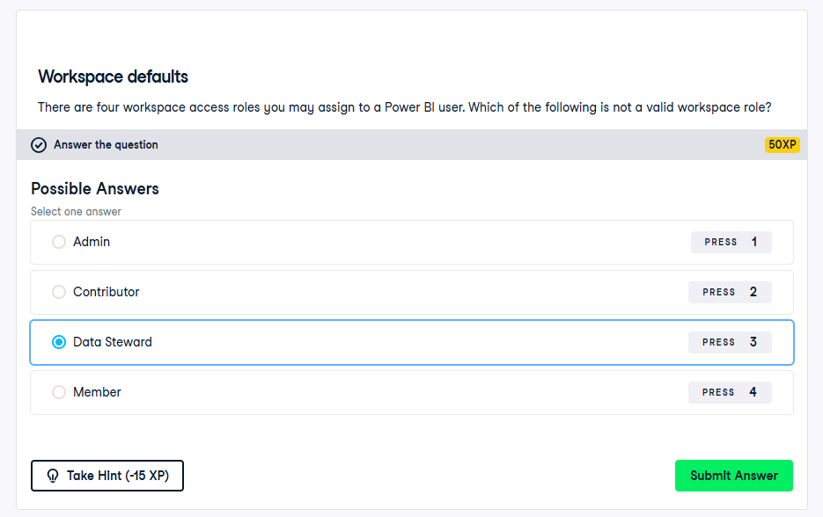

Steps to publish an application

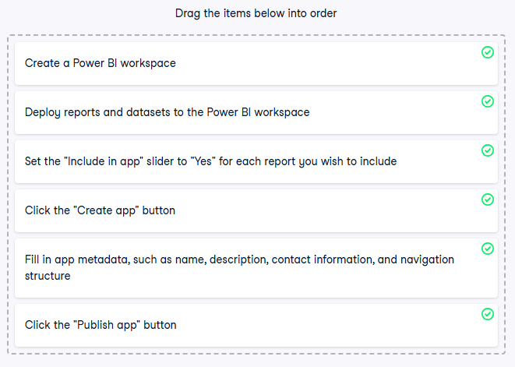

Ways to get an application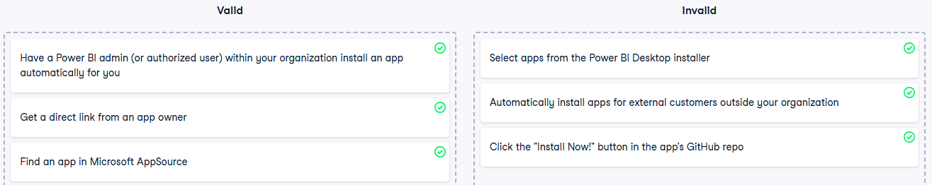

**Securing Content in Power BI Service**

Sensitivity labels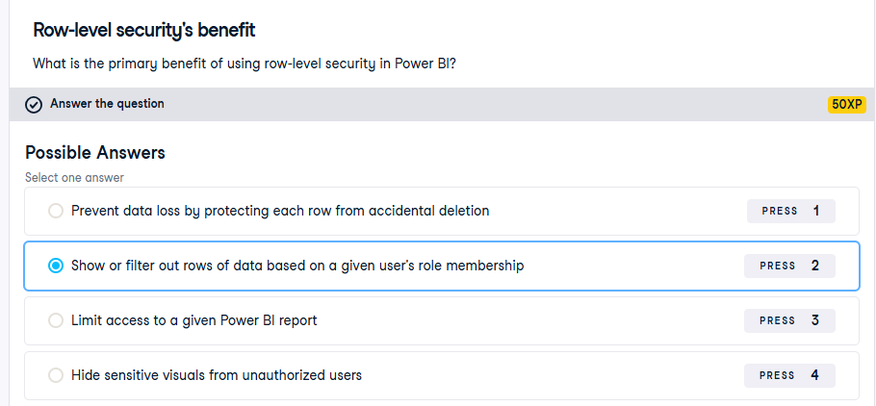

Row-level security’s benefit

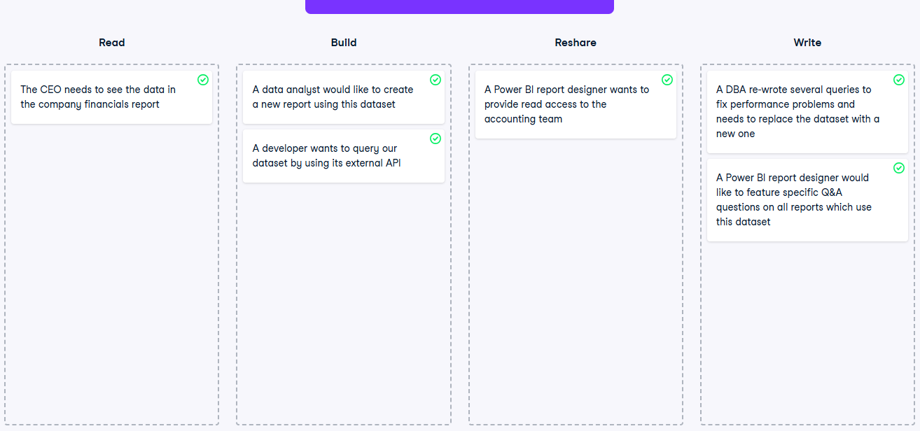

Matching permissions with activities

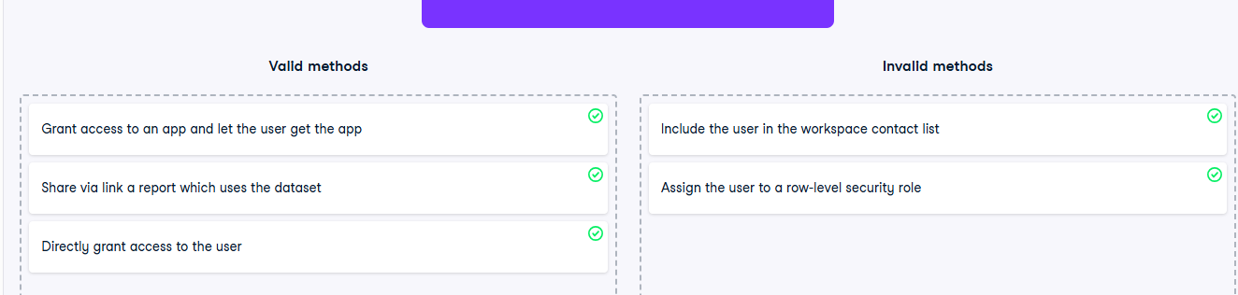

Row-level security and permissions

**Exercise 2.1** 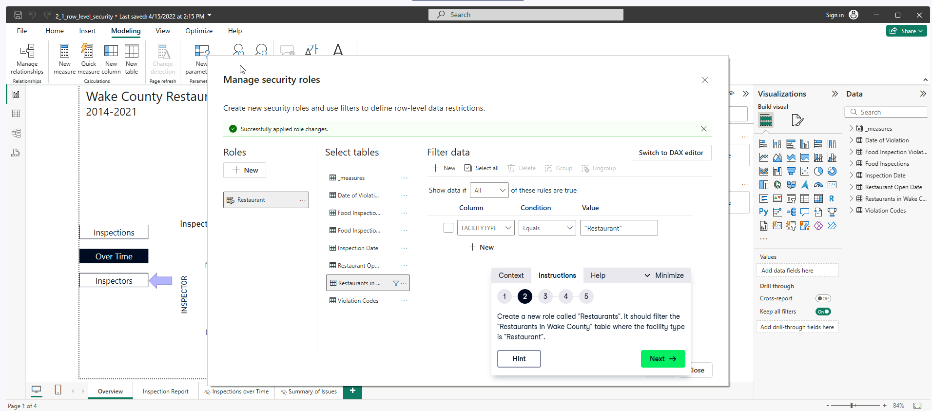

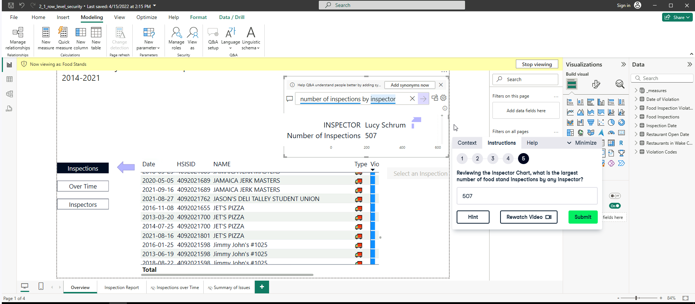

Ensure, you are viewing for “Food Stands”, before performing the QA. 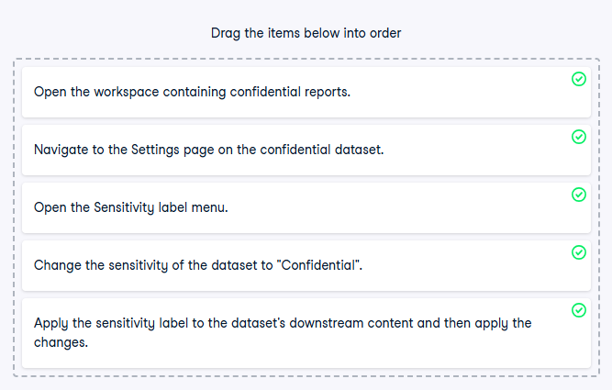

Setting sensitivity labels

**Enabling Users in Power BI**

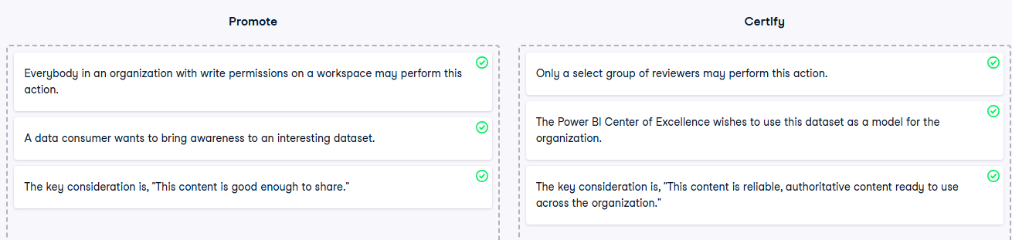

Personalizing a visual

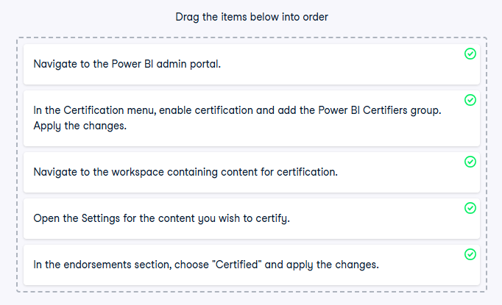

Certify content 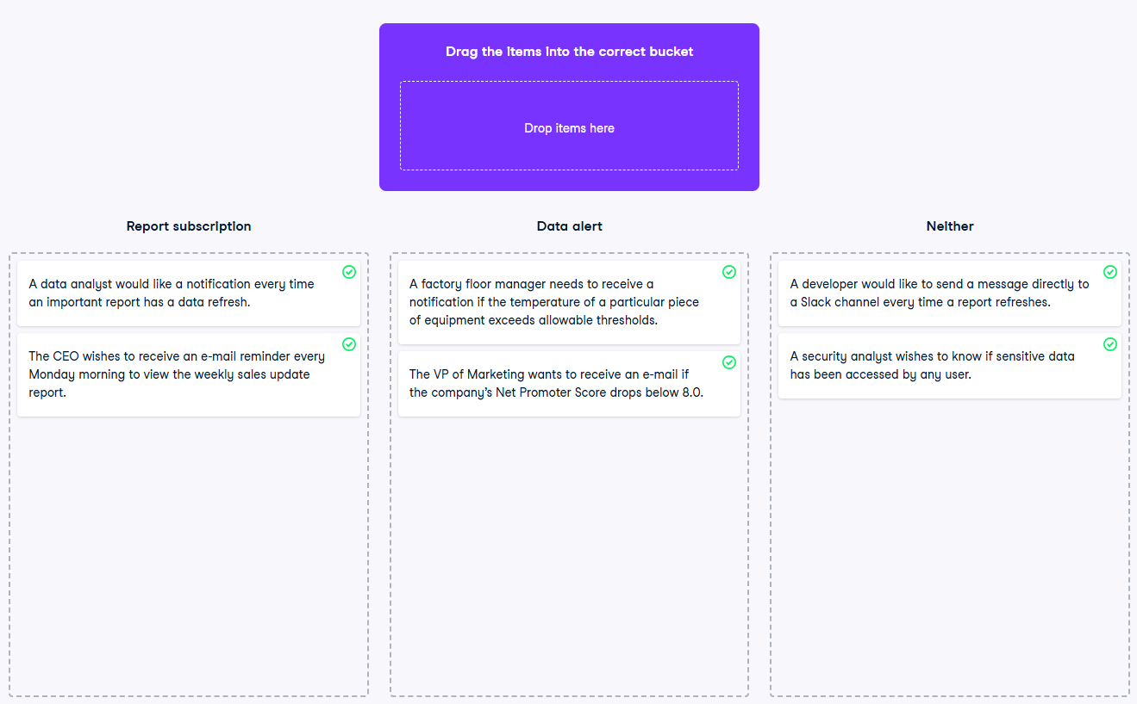

Subscriptions and data alerts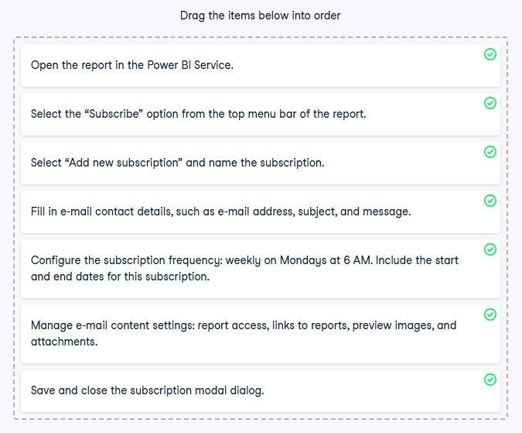

Subscribing to a report